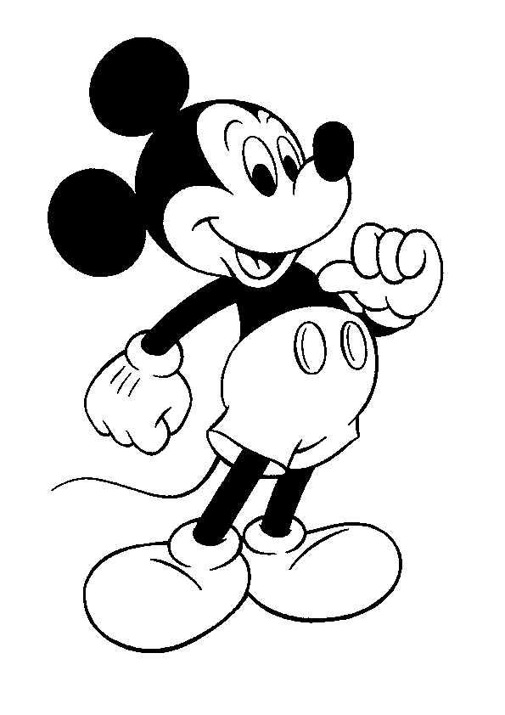
Media Applications 1- Mickey
mfarrell@iwacademy.org
Ms. Farrell
Lap 5: Designing and printing your own 3D object

Lap 5 Essential Question:
How do you design a 2D image and convert it into a 3D image?
How do you print a 3D object using a 3D printer?

Late Assignments from Lap 5
Are all due by the last class day on Performance Assessment Day.
Failure to turn in late or missing work by the last class day on Performance Assessment Day will result in a zero for that particular assignment – no exceptions.
Overview
Students will explore Adobe Illustrator create a design an ornament of their own choosing. Students will use Adobe Illustrator tools to create their own design. Once their design is complete, students will place their Illustrator design into Adobe Photoshop. From there, they will be able to convert their 2-Dimmensional image into a 3-Dimmemsional image. Once they have their image converted into a 3D image, students will then print their 3D design on the 3D printer. Students will also be learning how to export their image into the proper file format so that it can be printed on a 3D printer.

Rationale
Students will be able to design their own ornament in Adobe Illustrator, and then eventually convert their 2D image into 3D using Adobe Photoshop. This project will challenge students to not only create a design of their own choosing, but they will also have to use creative skills to create their design. Students will also have to use creative problem solving skills to design a 2D ornament to be printed in 3D without any errors. Students will also be learning how to export their 3D image into an STL file, which is the same file extension that will be used to 3D print on the Incarnate Word Academy 3D Printers.

Learning Goals
- Students will design a 2-Dimensional (2D) ornament of their own choosing in Adobe Illustrator.
- Students will be creating an original drawing in Illustration software.
- Students will learn to place an Illustrator image into Adobe Photoshop.
- Students will convert their 2D image into a 3D image.
- Students will learn how to export a 3D image into an STL File.
- Students will print their 3D STL file using the 3D printers.
- Students will challenge themselves while designing a 2D design and converting it to a 3D design.
- Student will create a presentation that documents their design process and 3D printing steps.
Lap 5 Formative Assessments
Formative Assignments due throughout this LAP
- Check Point 1 (Done in Open Lab)  - Check Point 2 (Done in Open Lab) | Due dates will be listed on calendar.

Lap 5 Summative Assessment
Lap 5 Essential Question:
How do you design a 2D image and convert it into a 3D image?
How do you print a 3D object using a 3D printer?
Students will be using their current design knowledge to design and print an ornament. Students will be using Adobe Illustrator to design their own 2D ornament, which will be converted into a 3D Image using Adobe Photoshop to be printed on a 3D printer. Students will be learning new skills on Adobe Illustrator and Adobe Photoshop to successfully design and print their ornament. Students will be required to use creative problem solving to create a successful 2D image in Illustrator, and then covert it into the correct file type in Photoshop to make it a 3D image. Students will then be exporting their new 3D image into a STL file, which is required to print on a 3D printer. Students will then print their STL file, which is their 3D image, on the 3D printers at Incarnate Word Academy. | C Day 11/2

Open Lab
Requirements
During this LAP, students will be required to attend Open Labs for two check-ins for this LAP project.  For these check-in’s, students will be required to attend two open labs throughout this LAP. All two of the check-ins will be due at the end of this LAP, but there are not specific dates for each of the check-ins. The goal for this LAP’s check-ins is that the student can attend the two separate open labs when it works out best for her schedule. It will be up to the student to find two different open lab times for her check-ins. If a scheduling conflict is discovered, it is the student’s responsibility to talk to me about alternative check-in times.  Students who come in for their check-ins must be present for BOTH mods in the open lab. For example, if they choose just mod 9 for their check-in, they must attend another lunch mod for one check-in to be complete. | Check-in 1  C Day 11/2  Check-in 2  C Day 11/2

Enrichment
The Senior Directed One Acts
During LAP 5, students will have the opportunity to see “The Senior Directed One Acts” at Incarnate Word Academy. The show is Thursday, November 21 and Friday November 22 at 7:00 PM. Students seeing the One Acts can sign up on the sign-in sheet at the conclusion of the show. | November 21st and 22nd at 7:00 PM

Calendar of Events
Day 1
- Due at class time – Nothing at this time.  - What we are doing today – Today we will be reviewing LAP 5, going over any due dates, and explaining the project requirements.  - Assignment for next time – Students must have an 3D idea in mind to start creating next class. | G Day 10/29
Day 2
- Due at class time – Ornament design to start in class.  - What we are doing today –Students will be working on their 3D printed projects.  - Assignment for next time –None at this time. | H Day 10/30
Day 3
- Due at class time – Nothing at this time.  - What we are doing today –  - MICKEY WILL BE IN LEARNING COMMONS!  - Assignment for next time – Illustration design should be competed by next class. | A Day 11/5
Day 4
- Due at class time – None for this class.  - What we are doing today – Today is a workday for your 3D project!  - Students will continue working on their 3D printed projects. Students will learn how to export their design to an STL file, save it to a flash drive, and learn the printing process  - Assignment for next time – Student should have their project exported to an STL file at this time. | B Day 11/6 (Late Start)
Day 5
- Due at class time – Students should have their 3D design saved to an STL file. Students need to have their quote selected for the Cricut project.  - What we are doing today – Today students will start to learn about the Cricut Design Space.  - Assignment for next time – Nothing at this time. | C Day 11/7
Day 6
- Due at class time –Nothing at this time  - What we are doing today – Today in class, students will be finishing up their Cricut group project.  - Assignment for next time –Nothing at this time! | A Day 11/19
Day 7
- Due at class time – Nothing at this time!  - What we are doing today – Students should be finishing up their 3D printing project and slides.  - Assignment for next time –3D Printing | B Day 11/20 (Late Start)
Day 8
- Due at class time – 3D Printing Project is due TODAY!  - What we are doing today – Today students will be turning in their 3D Printing project and slides presentation.  - Assignment for next time –Nothing, new LAP! | 11/21 C Day

Coming up next…
Lap 6- Designing your own brand

