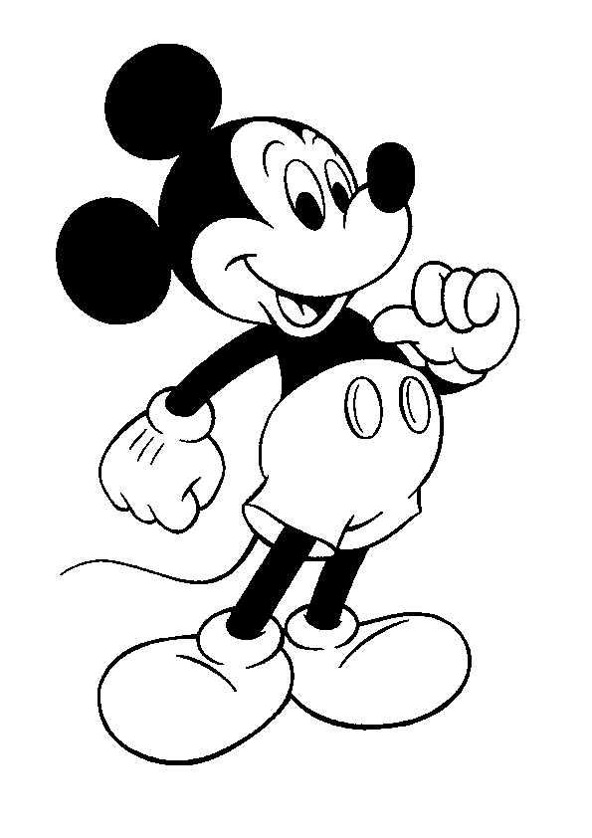
Media Applications 1- Mickey
mfarrell@iwacademy.org
Ms. Farrell
Lap 4: Designing and Creating your own Posters

Lap 4 Essential Question:
How do you use your current InDesign knowledge and skills to develop your own poster?

Late Assignments from Lap 4
Are all due by the last class day on Lap 5.
Failure to turn in late or missing work by the last class day on Lap 5 will result in a zero for that particular assignment – no exceptions.
Overview
Students will explore the InDesign workspace and its use in creating print materials. This LAP will focus on using their current knowledge and skills and apply it to designing their own posters. Students will use various fonts, pictures, colors, and other design elements to apply to their posters.

Rationale
Students will be able to use defined project requirements to create three posters of their own design. Students will explore existing posters to decide on a various quotes, images, and designs to put on their poster. This project will challenge students to be creative and design something that fits their own personality and design skills.

Learning Goals
- Students will design three different posters of their choosing.
- Students will use text objects and associated features.
- Students will determine and apply character and word spacing.
- Students will adjust or change color in a layout.
- Students will import graphics from various sources.
- Students will create original drawings in illustration software (Adobe Illustrator)

Lap 4 Formative Assessments
Formative Assignments due throughout this LAP
- Check Point 1 (Done in Open Lab)  - Check Point 2 (Done in Open Lab) | Due dates will be listed on calendar.

Lap 4 Summative Assessment
Lap 4 Essential Question:
How do you use your current InDesign knowledge and skills to develop your own poster?
Students will be using their current knowledge and skills to design three posters of their own choosing. Students will be asked to research posters and decide on different quotes, and even use different ideas on color choices, font choices, etc. Students will NOT be recreating posters that exist, but researching different skills that are on posters. Students will be required to include at least five different fonts, five different swatches, one image, one drawn design, one gradient, and one border into their design. Students may use more than these required elements, these are just the required minimum. Students will also be required to have one of their posters be in a print style poster. This means that the print design is heavily focused on illustrations and calligraphic fonts instead of photo backgrounds. Examples of all poster types will be presented in class. | C Day 10/18

Open Lab
Requirements
During this LAP, students will be required to attend Open Labs for two check-ins for this LAP project.  For these check-in’s, students will be required to attend two open labs throughout this LAP. All two of the check-ins will be due at the end of this LAP, but there are not specific dates for each of the check-ins. The goal for this LAP’s check-ins is that the student can attend the two separate open labs when it works out best for her schedule. It will be up to the student to find two different open lab times for her check-ins. If a scheduling conflict is discovered, it is the student’s responsibility to talk to me about alternative check-in times.  Students who come in for their check-ins must be present for BOTH mods in the open lab. For example, if they choose just mod 9 for their check-in, they must attend another lunch mod for one check-in to be complete. | Check-in 1  C Day 10/18  Check-in 2  C Day 10/18

Enrichment
DIY Binder Cover
Students will have the opportunity to design a binder cover on Adobe InDesign or Illustrator. | C Day 10/18

Calendar of Events
Day 1
- Due at class time – Nothing at this time.  - What we are doing today – Today we will be reviewing LAP 4, going over any due dates, and explaining the project requirements. Next we will be finishing up our Photoshop activity from last class.  - Assignment for next time – Students must have three different poster designs prepared for next class. | B Day 10/3
Day 2
- Due at class time – three different poster designs must be ready in class.  - What we are doing today – Today we will be going over a few more tools on Adobe Illustrator. Then, students be reviewing File Place between Adobe Illustrator and Adobe InDesign. Then, students will be learning how to search for copyright safe pictures. Finally, students will have the rest of class to work on their posters.  - Assignment for next time –None at this time. | C Day 10/4
Day 3
- Due at class time – Nothing at this time.  - What we are doing today – Students will be working on their posters.  - Assignment for next time – None for next class. | G Day 10/10
Day 4
- Due at class time – None for this class.  - What we are doing today –Today we will be learning about character and work spacing such as tracking, kerning, leading, horizontal scale, and vertical scale.  - Assignment for next time – Nothing at this time. | H Day 10/11
Day 5
- Due at class time – Nothing at this time.  - What we are doing today – Students will continue working on their posters.  - Assignment for next time – Nothing at this time. | B Day 10/17
Day 6
- Due at class time – ALL THREE POSTERS ARE DUE TODAY!  - What we are doing today – Students will be printing their posters today in class. Then, students will be sharing their favorite of the three posters and why it’s their favorite.  - Assignment for next time – Nothing, new LAP next class. | C Day 10/18

Coming up next…
Lap 5- Designing a model for 3D Printing

